**SETTING UP APPLICATION ENVIRONMENT**

**Create Flask Project**

|  |  |
| --- | --- |
| **Team ID** | PNT2022TMID52529 |
| **Project Name** | Inventory Management System |
| **Date** | 24 OCT 2022 |

**Step 1.** Install Python latest version from python.org

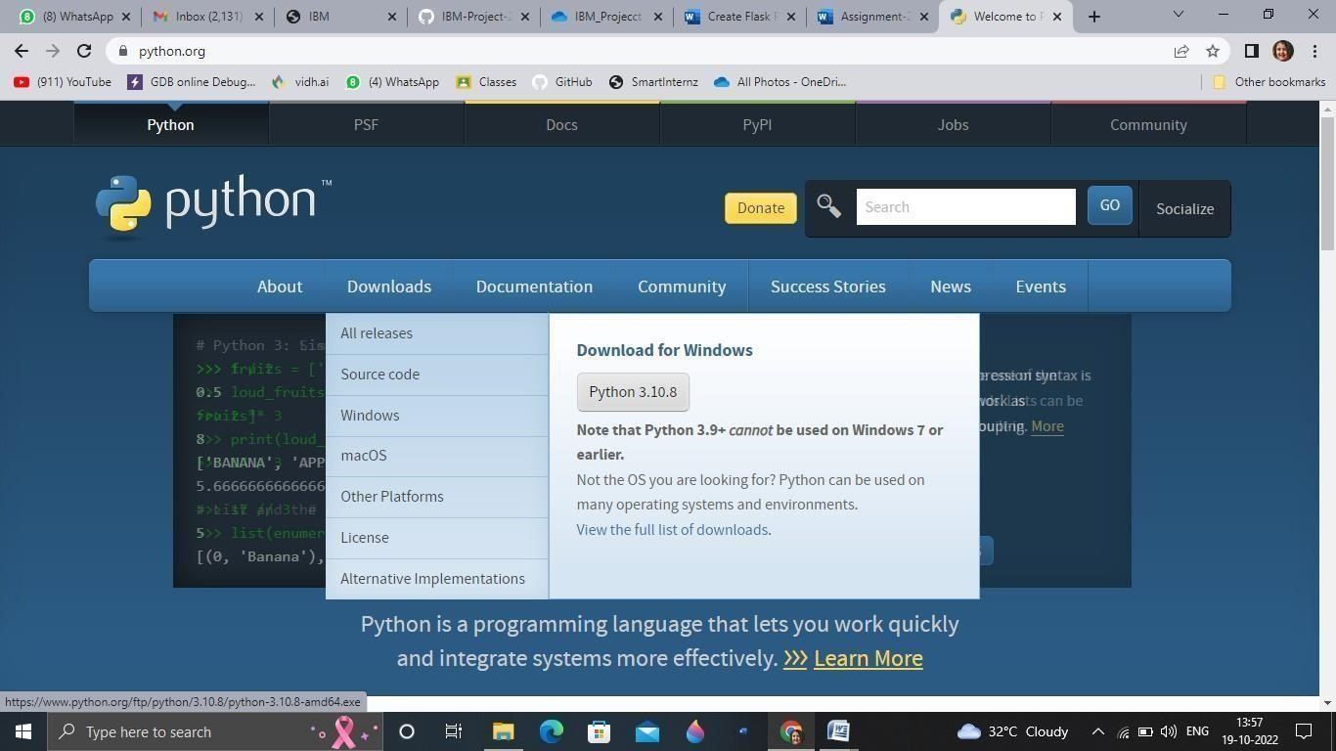

**Step 2**. Download Anaconda from [https://www.anaconda.com/a](https://www.anaconda.com/)nd install it by running the .exe file

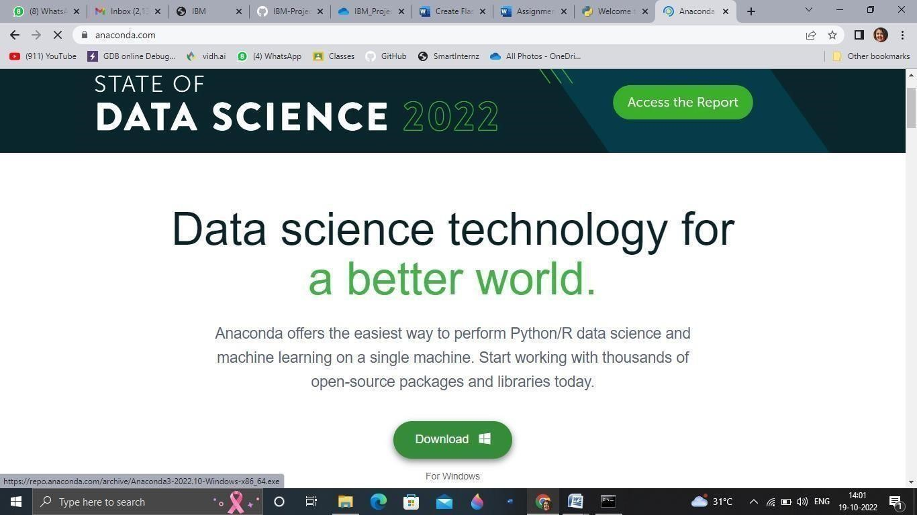

**Step 3**. Install Flask using command pip install flask

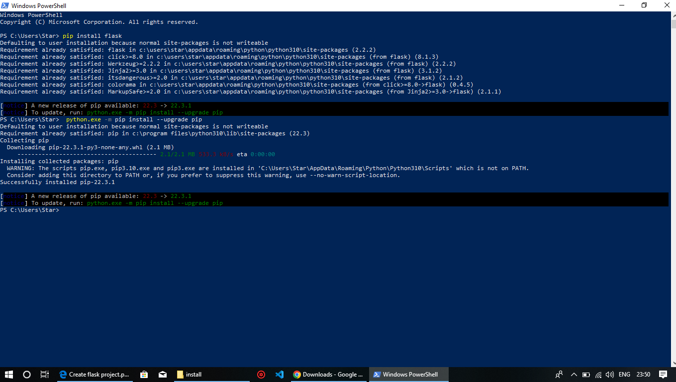

**Step 4**. Open a new Python file and start coding

from flask import Flask

app = Flask(__name__)

@app.route('/')

def index():

     return 'hello world'

app.run(host='0.0.0.0', port=81)

**Step 5**. Run the Python file using command python filename.py

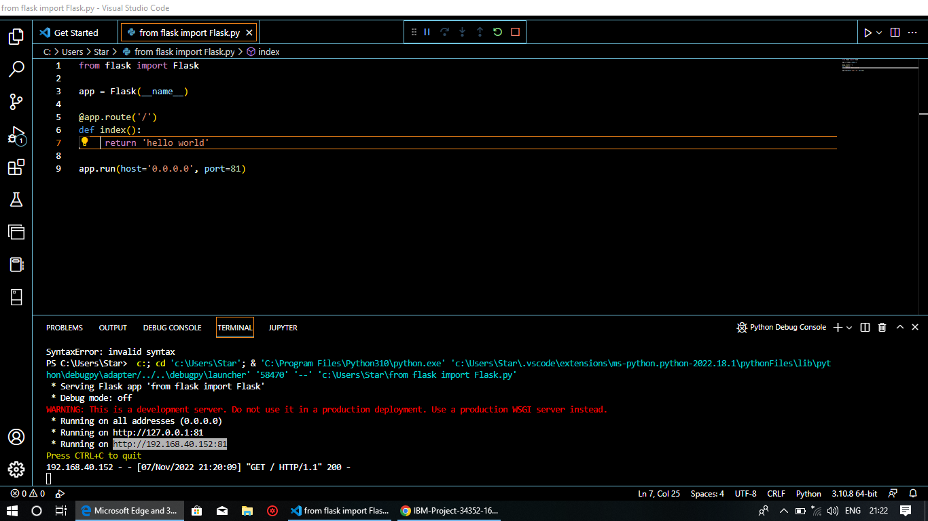

**Step 6**: Open the IP in browser

